SIMATS ENGINEERING
ASSESSMENT TOOL 2

COURSE NAME: Database Management Systems
COURSE CODE: CSA0508

COURSE OUTCOME COVERED

CO1: Analyze DBMS architecture, different data models, schema types, and design ER/EER diagrams, relational schemas for case-based scenarios by identifying entities and relationships. (BL1, BL2)

Activity Tool : Concept Mapping (Medium)
Assessment Tool Weightage: 35%

Dr

QUESTIONS Total Marks: 50
Q.No | Question | Bloom's Level | Marks
1 | Construct a concept map linking the following terms: DBMS, Schema, Instance, Data Model, ER Diagram, Entity, Attribute, Relationship. | BL2 – Understand | 5
2 | Create a concept map for the three-level ANSI/SPARC architecture showing data independence at each level. | BL2 – Understand | 5
3 | Map the relationship between file-based systems and database systems, highlighting the problems solved by DBMS. | BL2 – Understand | 5
4 | Design a concept map for ER diagram components: entity, weak entity, attribute types, relationship types, and participation constraints. | BL2 – Understand | 5
5 | Construct a concept map comparing Hierarchical, Network, and Relational data models with their key properties. | BL2 – Understand | 5
6 | Develop a concept map for the EER model showing how it extends the basic ER model with generalization, specialization, and aggregation. | BL2 – Understand | 5
7 | Create a visual concept map for the DBMS software architecture, illustrating the flow from user request to data retrieval. | BL2 – Understand | 5
8 | Map the data models discussed in CO1 to real-world applications and explain the suitability of each model. | BL2 – Understand | 5
9 | Construct a concept map for schemas and instances, showing how they relate to physical and logical data independence. | BL2 – Understand | 5
10 | Design a concept map for the roles and responsibilities in a DBMS environment: DBA, End User, Application Developer. | BL1 – Remember | 5

Code of Conduct:

I Apsal Hameed (192524286) certify that this submission is my original work and that I have adhered to the guidelines specified for this assessment.
I understand that any violation of academic integrity rules will result in disciplinary action.

Signature of the student:
APSAL HAMEED

RUBRICS FOR CALCULATION:

Criteria | Weightage | Level 4 (Exemplary) | Level 3 (Proficient) | Level 2 (Developing) | Level 1 (Beginning)
Concept Identification | 25% | Identifies all key concepts from literature accurately and comprehensively | Identifies most key concepts with minor omissions | Identifies limited concepts; some are irrelevant or missing | Fails to identify essential concepts
Linkages | 25% | Establishes clear, meaningful, and accurate relationships between concepts | Shows correct relationships with minor gaps | Relationships are weak, unclear, or partially incorrect | No meaningful relationships established
Organization | 20% | Concepts are well-structured hierarchically with logical flow and grouping | Mostly organized with minor structural issues | Some organization but lacks clear hierarchy | No logical organization or structure
Integration of Literature | 20% | Integrates multiple studies effectively to show connections and comparisons | Shows some integration of literature | Limited integration; mostly isolated concepts | No integration of literature evidence
Clarity | 10% | Concept map is clear, neat, visually structured, and easy to interpret | Generally clear with minor readability issues | Clarity is reduced; difficult to interpret in parts | Poorly presented and hard to understand

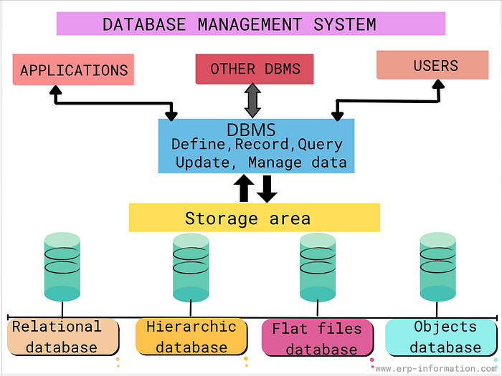
1. Concept Map: DBMS, Schema, Instance, Data Model, ER Diagram, Entity, Attribute, Relationship
Database Management System (DBMS)
- A software system used to create, store, retrieve, update, and manage databases.
- Uses a Data Model to organize and represent data.
- A Data Model defines how data is structured, stored, and related.
- An Entity-Relationship (ER) Diagram is used during database design.
- An Entity represents a real-world object such as Student, Employee, or Product.
- An Attribute describes the properties of an entity (e.g., Student_ID, Name, Age).
- A Relationship shows how two or more entities are connected (e.g., Student enrolls in Course).
- A Schema defines the overall logical structure of the database, including tables and relationships.
- An Instance represents the actual data stored in the database at a specific point in time.
- The DBMS uses the schema to manage database instances efficiently.

2. Concept Map: ANSI/SPARC Three-Level Architecture
ANSI/SPARC Architecture
- Divides the database into three levels.
- External Level provides different views for different users.
- Each user sees only the required part of the database.
- Conceptual Level represents the complete logical structure of the database.
- It defines entities, relationships, and constraints.
- Internal Level describes the physical storage of data on disks.
- It includes file organization, indexing, and storage techniques.
- Logical Data Independence allows changes in the conceptual schema without affecting external views.
- Physical Data Independence allows changes in storage methods without affecting the conceptual schema.
- This architecture improves flexibility, security, and maintainability.

3. Concept Map: File-Based System vs Database System
File-Based System
- Stores data in separate files.
- Causes data redundancy because the same data is stored multiple times.
- Leads to data inconsistency when files are updated separately.
- Makes data sharing difficult.
- Provides weak security.
- Backup and recovery are difficult.
- Data retrieval is slow and inefficient.

Database Management System
- Stores data in a centralized database.
- Reduces redundancy through normalization.
- Maintains consistency using constraints.
- Allows multiple users to access shared data.
- Provides security through authentication and authorization.
- Supports backup and recovery.
- Improves data integrity and performance.

4. Concept Map: ER Diagram Components
ER Diagram
- Contains Entities.
- Includes Weak Entities, which depend on strong entities.
- Has different Attribute Types:
  - Simple Attribute
  - Composite Attribute
  - Multivalued Attribute
  - Derived Attribute
- Represents Relationship Types:
  - One-to-One
  - One-to-Many
  - Many-to-Many
- Uses Participation Constraints:
  - Total Participation
  - Partial Participation

5. Concept Map: Hierarchical, Network, and Relational Data Models
Hierarchical Model
- Organizes data in a tree structure.
- Supports one-to-many relationships.
- Suitable for organizational hierarchies.
Network Model
- Organizes data as a graph.
- Supports many-to-many relationships.
- Suitable for interconnected data.
Relational Model
- Stores data in tables.
- Uses rows and columns.
- Supports SQL.
- Uses primary and foreign keys.

6. Concept Map: Enhanced Entity-Relationship (EER) Model
EER Model
- Extends the basic ER model.
- Supports Generalization, which combines similar entities into a superclass.
- Supports Specialization, which divides a superclass into subclasses.
- Supports Aggregation, which treats relationships as higher-level entities.
- Helps model complex real-world applications.

7. Concept Map: DBMS Software Architecture
User
→ Sends a query.
Query Processor
→ Parses and validates the query.
Query Optimizer
→ Chooses the most efficient execution plan.
Execution Engine
→ Executes the optimized query.
Storage Manager
→ Retrieves or updates data.
Database
→ Stores data permanently.
Result
→ Returned to the user.

8. Concept Map: Data Models and Real-World Applications
Hierarchical Model
- Used in file systems and organizational structures.
Network Model
- Used in social networks and telecommunication systems.
Relational Model
- Used in banking systems, hospital management, libraries, colleges, and e-commerce applications.
Each model is suitable based on its structure and relationship capabilities.

9. Concept Map: Schema, Instance, and Data Independence
Schema
- Defines the database structure.
- Changes rarely.
Instance
- Represents the current contents of the database.
- Changes frequently.
Logical Data Independence
- Allows changes in the conceptual schema without affecting user views.
Physical Data Independence
- Allows changes in physical storage without affecting the logical schema.

10. Concept Map: Roles and Responsibilities in a DBMS Environment
Database Administrator (DBA)
- Creates and maintains the database.
- Controls security.
- Performs backup and recovery.
- Monitors performance.
Application Developer
- Designs database applications.
- Writes SQL queries.
- Develops user interfaces.
- Maintains software.
End User
- Accesses the database.
- Inserts, updates, deletes, and retrieves data.
- Uses applications to perform daily tasks.

